What is Delfinovin?

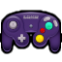
Delfinovin is a software that can read data sent from Nintendo Gamecube Adapters, and translate it into an XInput device for use in modern games.

How do I set it up?

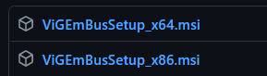
Firstly, Delfinovin uses ViGEmBus to create the virtual XInput devices.
- Download and install the latest release of ViGEmBus.
Delfinovin also uses WinUSB to communicate with the Gamecube Adapter directly.
- Download and run the latest version of Zadig.
- Under "Options", enable "List All Devices” and select WUP-028 from the list of devices.
- Choose WinUSB in the right dropdown list and then click on "Replace Driver."
- Accept any prompts and wait for it to install and then restart Delfinovin.

How do I use Delfinovin?

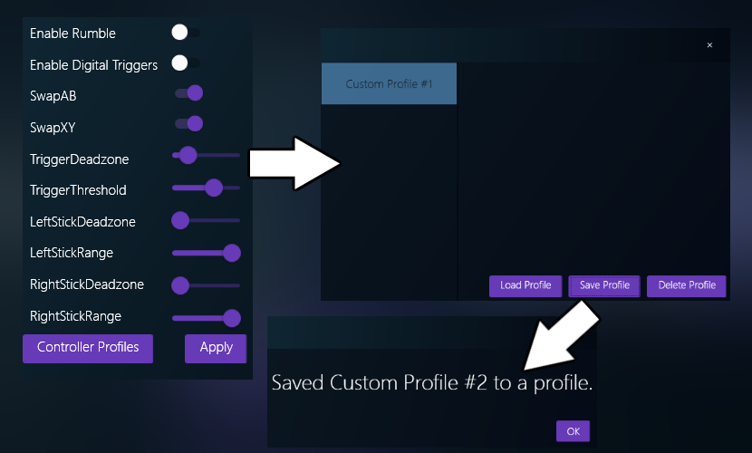
Delfinovin automatically detects and creates XInput devices as you plug controllers into your Gamecube Controller adapter. There are a number of settings that can be set and applied to the controller by clicking on “Edit” button for the corresponding controller port and clicking "Edit Settings." in the context menu.
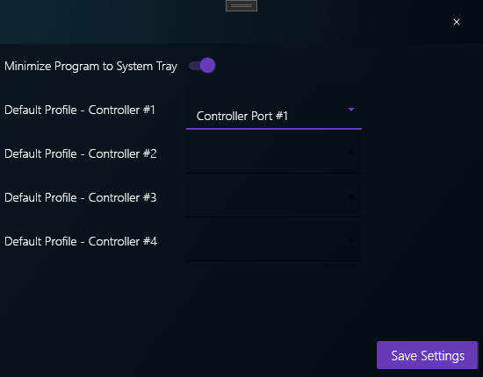
These settings can then be saved to a profile that can be managed from "Controller Profiles" menu. Save settings using the menu, and set it as a default profile using the "Settings" menu in the bottom left of Delfinovin.

After loading a profile from the Profile menu using the “Load Profile” button, apply it to the controller by pressing the “Apply” button from the settings dialog.

What do the settings mean?

For the controller settings:
- Enable Rumble - When enabled, controllers will receive haptic feedback (rumble.)
- Enable Digital Triggers - When enabled, the digital button of the triggers will be enabled. Button/trigger layouts will be swapped.
- SwapAB / SwapXY - Swaps the button layout of the face buttons.
- TriggerDeadzone - The percentage of the button that registers no input.
- TriggerThreshold - The amount that you have to press the button to register a full press.
- LeftStick/RightStick Deadzone - The percentage of the stick that registers no input.
- LeftStick/RightStick Range - The size of the virtual stick. Larger values mean a further stick move is required.
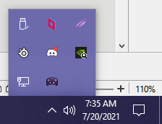
For application settings:
- Minimize Program to System Tray - When enabled, Delfinovin will minimize itself to the system tray. Right-click the icon to open a menu with options to open/close the program.
- Default Profile - Controller #1-4 - Load the selected setting profiles when starting Delfinovin and apply them to the corresponding controller port.

I'm interested in contributing to Delfinovin! Where do I do that?

Firstly, thank you! The project would not be possible without all of the support from the various community members who contribute their assistance to the development.

- You can contribute to Delfinovin on Github by opening pull and feature requests and opening issues documenting bugs.

- If you are interested you can also contribute financially through the ko-fi/paypal links. Anything is appreciated!

How did you come up with the name "Delfinovin?" (Dell-fee-no-vin)

Delfino Island is the main locale for Super Mario Sunshine, one of the biggest games on the Nintendo Gamecube. In Italian, "Delfino" can mean "Dolphin." The suffix "-vin" in Dutch means "fin." Dolphin fin! Dolphins use their fins to control their movement just as you can use this program to control Gamecube Controllers. Delfinovin!

Issues

- My gamecube adapter (WUP-028) doesn't show up in the Zadig menu / in Delfinovin!
  - If you are using a third party adapter, switch it into Wii U/Switch mode from PC mode, if possible.
  - If you are using an adapter with two USB plugs, that you have plugged the correct one into your PC. If that doesn't work, try different ports.
  - Ensure no other application (e.g. Dolphin, Yuzu, etc.) is taking control of the device.i
- The installer for ViGEmBus ended prematurely, how do I fix that?
  - Make sure you downloaded the proper version for your PC.
    - If your PC is 32bit, download the x86 setup. 64bit downloads the x64 version.
    - You can find out which version you have under the "About my PC" menu in your System settings.
  - If you're using a ViGEmBus version past 1.17, these only work with Windows 10 and onwards. Fall back to v1.16 if you need it on Windows 7/8.
  - ViGEmBus unfortunately doesn't work on ARM based systems. So, no M1 Macs and some ultra slim laptops.
- My sticks feel slow and or don't reach the edges!
  - Since Gamecube Controllers use a different cutout for the stick (octagonal gates versus circular ones), the controllers can't reach the same ranges as a normal controller. You can modify these ranges by either
    - Having Delfinovin find them for you automatically
      - Click “Edit”, then click on "Calibrate Controller" and rotate your sticks. Then finalize the calibration by opening the Edit menu and then click on "Finish Calibration."
    - Manually trying to find the range by modifying the LeftStick/RightStick range value.
- My sticks are jittering a lot!
  - This often happens when controllers have a low range value or no deadzone value applied.
    - Deadzones are a portion (often a circle) in the middle of the stick that register as a neutral, centered input.
  - Try increasing the value of the LeftStick/RightStick deadzone value.

